Sample the function f(r,theta)=h*g 1
clear
clc

Sample the function f(r,theta)=h*g
N2=15; %number of sample points in angular direction
N1=383; %number of sample points in radial direction
M=(N2-1)/2; %highest order of bessel function
R=40;% space limit
Wp=30; % band limit
a=0.1;
load('zeromatrix.mat')
theta=thetamatrix_SpaceLimited(N2,N1); %Sample point in angular direction in space domain.
r=rmatrix_SpaceLimited(N2,N1,R,zeromatrix);%Sample point in radial direction in space domain.
psi=psimatrix_SpaceLimited(N2,N1);%Sample point in angular direction in frequency domain.
rho=rhomatrix_SpaceLimited(N2,N1,R,zeromatrix);%Sample point in radial direction in frequency domain.
[x,y]=pol2cart(theta,r); %sample points in Cartesian coordinates in space domian
[x1,y1]=pol2cart(psi,rho); %sample points in Cartesian coordinates in frequency domian
%Dicretizing the function
for ii=1:N2
for jj=1:N1-1
f(ii,jj)=exp(-r(ii,jj)^2);
end
end
% DFT
fnk=circshift(fft(circshift(f,M+1,1),N2,1),-(M+1),1);
% DHT
for n=-M:M
ii=n+M+1;
zero2=zeromatrix(5001-abs(n),:);
jnN1=zero2(N1);
if n<0
Y=((-1)^abs(n))*YmatrixAssembly(abs(n),N1,zero2);
else
Y=YmatrixAssembly(abs(n),N1,zero2);
end
fnl(ii,:)=(Y*fnk(ii,:)')';
Fnl(ii,:)=fnl(ii,:)*(2*pi*(i^(-n)))*(R^2/jnN1);
end
% IDFT
TwoDFT=circshift(ifft(circshift(Fnl,M+1,1),N2,1),-(M+1),1);
%creating a discrete 2D Fourier transform
for ii=1:N2
for jj=1:N1-1
trueFunc(ii,jj)=pi*exp((-rho(ii,jj)^2)/4);
end
end
%calculating the dynamic error from transform and true function
error= 20*log10(abs(trueFunc- TwoDFT)/max(max(abs(TwoDFT))));
figure(1)
subplot(2,1,1)
surf(x1,y1,abs(trueFunc))
title('\fontsize{24}Sampled Continuous Forward Transform')
subplot(2,1,2)
surf(x1,y1,abs(TwoDFT))
title('\fontsize{24}Discrete Forward Transform')
figure(2)
surf(x1,y1,error)
xlabel('x');
ylabel('y');
zlabel('db')
str=sprintf('Error distribution with N2 = %d, N1 = %d,R= %d, a= %d ', N2,N1,R,a);
title(['\fontsize{24}Error distribution with N2=',num2str(N2),', N1=',num2str(N1),', R=',num2str(R), ', Wp=',num2str(Wp)]);
mean1=mean(mean(error)); % Average dynamic error
max1=max(max(error)); % Maximum dynamic error
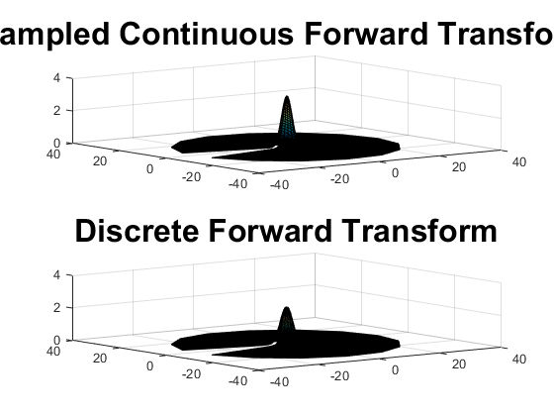
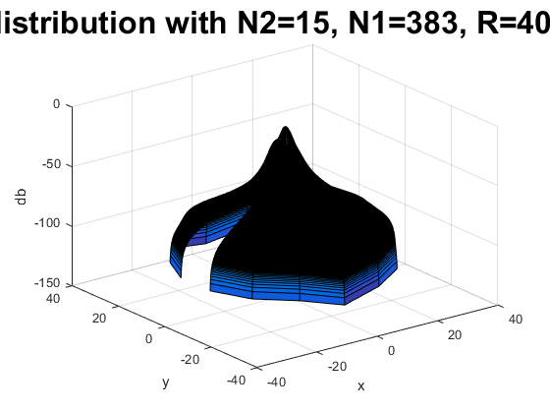
Published with MATLAB?R2015b

